
Updated 8/21/24

Setting up accessibility testing tools
As part of the digital accessibility testing workflow, you will use several tools to determine whether the website and web, native mobile, and desktop applications meet accessibility guidelines.
MNIT DOT recommends that anyone testing applications use the following tools for verification testing. Using the same set of tools will ensure repeatable methods for accessibility risk assessment and testing.
- axe DevTools - A free DevTools browser extension for Chrome, Firefox, or Edge to test web-based applications and help identify and resolve common accessibility issues.
- Colour Contrast Analyzer (CCA) - a free color contrast checker that tests content for color contrast WCAG compliance. It is available in the Software Center
- NVDA screen reader - A free screen reader to test for barriers that affect people with vision disabilities. It is available in the Software Center.
- Windows Magnifier - The Magnifier lets you zoom in on parts of the page to verify that they do not cause functional errors, such as blocking essential on-screen elements and content. It is available within the Windows OS.
- PEAT (Photosensitive Epilepsy Analysis Tool) - This free tool helps determine whether animations or videos are likely to cause seizures.
Before you start testing, you must install and set up the accessibility testing tools to ensure accurate results. Follow the setup outline here to get started.

Quick links to the various tools:
Testing tools for desktop
- NVDA (Non-Visual Desktop Access)
- Windows Magnifier on Windows 11
- axe Browser Extension
- PEAT (Photosensitive Epilepsy Analysis Tool)
- Color Contrast Analyzer (CCA)
Testing tools for mobile
- VoiceOver on iOS (iPhone and iPad)
- TalkBack on Android

Testing tools for desktop

NVDA (Non-Visual Desktop Access)
NVDA is a screen reader and can be downloaded from the Software Center. NVDA works well with Chrome, Firefox, and Edge.
The steps below will get you up and running.

Resources
- NVDA User Guide
- Deque’s Quick Reference Guide: NVDA for Windows Keyboard Commands

Installation
- Go to the Start menu and open the Software Center application.
- From the Applications window, search for NVDA.
- Select the Install button.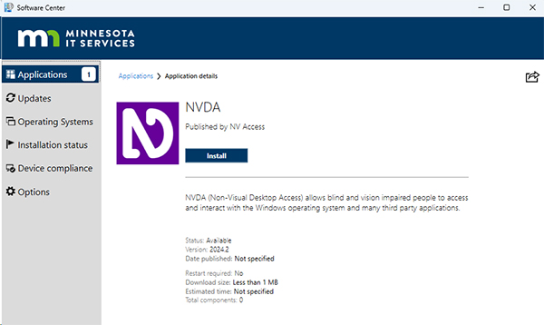
Note: To complete the installation, you must submit a Service Hub work request to complete the installation. Installation requires admin access to complete.

Launching NVDA
When launching NVDA for the first time, follow the Configuring NVDA instructions on the WebAIM webpage to set up the application for screen reader testing.

NVDA modifier key
Some keyboard shortcuts require using the NVDA modifier key. By default, both the Numpad Insert key and the Insert key are set as NVDA modifier keys, but you can also designate the Caps Lock key as an additional NVDA modifier key.
Attention! The instructions below use the CAPS LOCK as the NVDA modifier key.
Setting modifier key to Caps lock
- Open NVDA
- Go to the general setting by selecting CAPS LOCK + Crtl + g
- In the Categories column, select Keyboard.
- Under the Select NVDA Modifier Keys title, check caps lock.
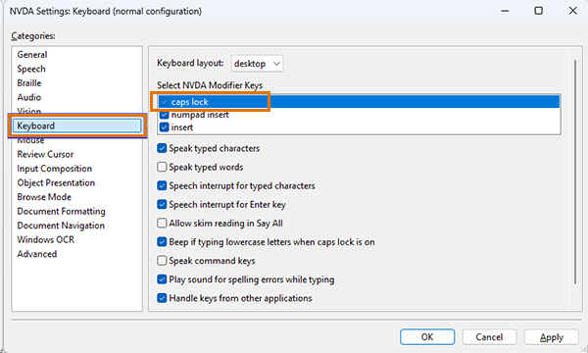

Adjusting the Voice
By default, NVDA will use the built-in voices provided by Microsoft. Altering the parameters of the voice may be helpful, for example, if you wish to slow the speaking voice down for a demonstration, increase the volume, or change the voice entirely.
- Go to General Setting by selecting CAPS LOCK + Crtl + g.
- In the Categories column. Select Speech. Adjust the speech rate, volume, and voice to your preference.
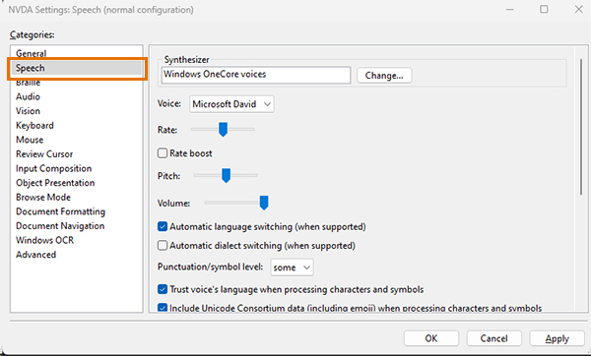

Speech Viewer
The NVDA speech viewer is a valuable tool for screen reader testers. Enabling the Speech Viewer opens a window that shows everything NVDA states, which is helpful for sighted users. The Speech Viewer also allows you to take a screenshot or a screen recording when reporting an issue.
- Open the NVDA Menu by pressing CAPS LOCK + n.
- Navigate to Tools and Select Speech Viewer. Check the "Show speech viewer on startup” box to enable the speech viewer to appear on startup. The speech viewer will open when NVDA is started.
  - A window will appear, updating in real-time with the content that NVDA speaks.
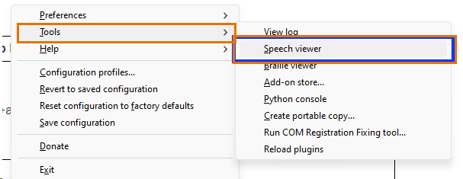

Windows Magnifier on Windows 11
Windows Magnifier is a screen magnification tool built into the Windows operating system. It provides a zoomed-in view of a select part of the screen at up to 1600% zoom. By default, it opens on the entire screen and will follow your mouse pointer, keyboard entry, and text cursor.
Attention! Do not use Windows Magnifier when checking zooming and magnification in a web browser.
Using Magnifier on Windows 11
There are two different ways you can turn Windows Magnifier on.
Using the Keyboard
- To turn it on Magnifier.
  - Press the Windows logo key + Plus sign (+).
- To turn off the Magnifier.
  - Press the Windows logo key + Esc.
Using the Mouse
- Select Start > Settings > Accessibility > Magnifier, then turn on the Magnifier switch.
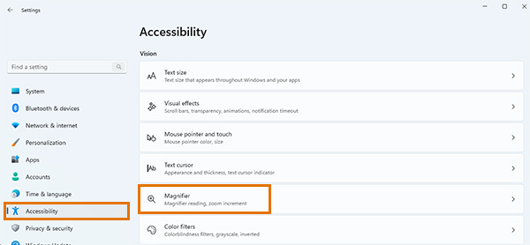

axe Browser Extension
axe DevTools browser extension automates accessibility testing for web-based applications to help identify common accessibility issues.

Installation
- Open Chrome, Edge or Firefox browser.
- Go to Deque’s browser extension webpage.
- Scroll to the bottom of the page and select the Install free extension for Chrome, Edge, and Firefox browsers.
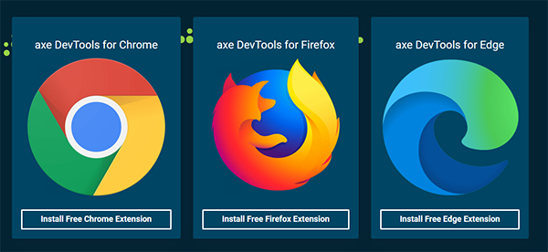
Notes:
- The usage and installation are identical for axe DevTools and axe DevPro tools.
  - If you have installed the Axe extension and upgraded to Axe Pro, you only need to sign in using the account with the Axe Pro subscription. No further installation is required. The features will be unlocked automatically.

Setting up axe DevTools
You will only need to do this once.
- Open Chrome, Edge, or Firefox browser.
- Open the browser’s Developer Tools by pressing Ctrl + Shift + I on a keyboard or right-click on the page and select Inspect in the pop-up window.
- Select the Axe DevTools tab in the developer tools menu.
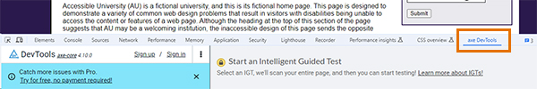
- Activate the "kebab" ⋮ button in the left panel (the accessible name is "Options") and choose Settings.
- Go to Rules and Issues > Best Practices on the right-hand page.
- Select Enable.
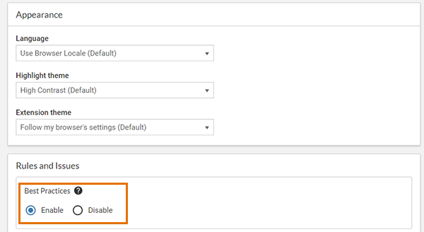

Using axe DevTools
- Open the browser’s Developer Tools by pressing Ctrl + Shift + I on a keyboard or right-click on the page and select Inspect in the pop-up window.
- Select the Axe DevTools tab in the developer tools menu.

- Select the Full Page Scan bottom.
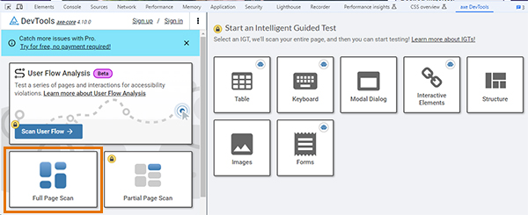
  - Make sure Best Practices is on. If it is not, select Best Practices and Re-run the scan.
  - When the scan is complete, you will see the total number of issues on the page and the number of issues grouped by severity.
- On the left-hand side of the Axe DevTools, you’ll see an overview of the results.
  - On the left-hand pane, you have a total of the issues found, categorized by type. When you select an issue, the accordion will open, showing:
    - The “Highlight” button will highlight the locale on the web page where the issue is.
    - A description of the issue with a link ("more information") to additional info available for free on Deque University.
    - A snippet of the code that has caused the issue.
      - The “</>” button next to the snippet will bring you to the problem code in your browser’s page inspector.
    - Guidelines for fixing the issue.
    - Information about the severity of the issue and which accessibility guidelines are being violated (e.g., WCAG 2.1, Section 508, etc.).
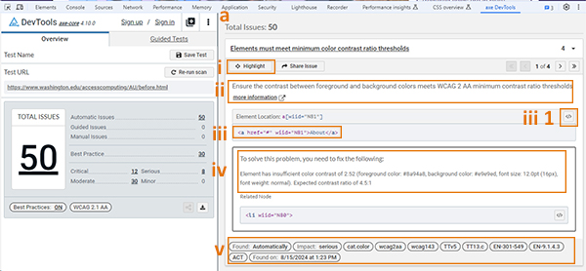
- Record the results in the Accessibility testing report spreadsheet.

Browser Developer tools
Every modern web browser includes a suite of developer tools. These tools are built directly into the browser and are browser-dependent. Most of these tools are shared among various browsers and do a range of things, from inspecting elements of HTML, CSS and accessibility checks.
For our purposes, we will focus on the Chrome and Firefox browsers.
Note: MS Edge developer tool mirrors Chrome’s developer tool.

How to open the developer tools.
To open the browser developer tools, choose one of the three methods.
- Place your cursor over the browser window where you want to inspect, right-click the desired element on the page and select Inspect from the pop-up window.
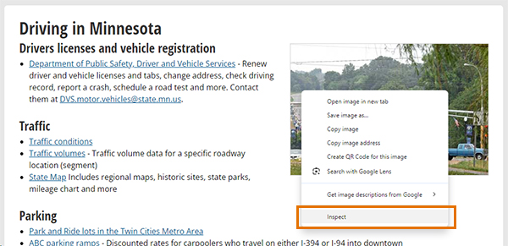
- Using your keyboard, Select Ctrl+Shift+I or F12.
- Select the three dots (Chrome) or hamburger menu (Firefox) in the top right corner of the browser window, then select More Tools and Developer Tools.
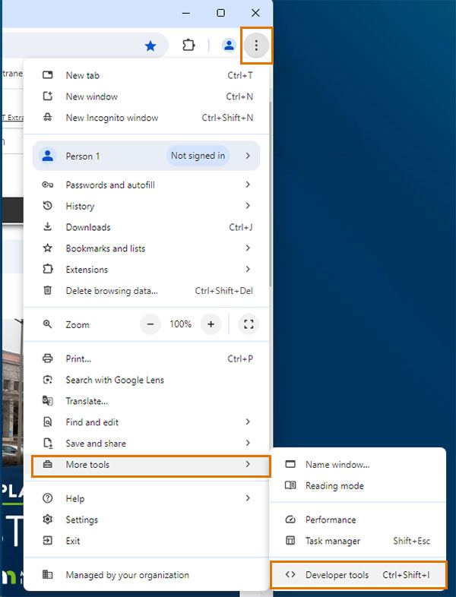

Accessing the DevTools Accessibility Pane
- Open Developer tools.
- Within the Developer tools Pane, select the Accessibility tab. If the accessibility tab is not visible, you must select arrows >> to reveal the tab.
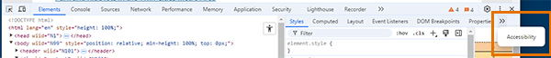
The Accessibility features reference the webpage provides detailed information on using the accessibility feature in the developer tools.

PEAT (Photosensitive Epilepsy Analysis Tool)
PEAT is used to analyze videos and animated content for potentially seizure-inducing flashes or movement.

Installation
- PEAT does not need to be installed directly onto your system. Visit the PEAT website and scroll down until you see the Free download link.
- Select the download button. This will download a zip file to your downloads folder.
- Open the download and PEAT zip folders and follow the installation steps.
Refer to PEAT’s user guide to understand all of its features.

Color Contrast Analyzer (CCA)

Installation
- Go to the Start menu and open the Software Center application.
- From the Applications window, search for CCA.
- Select the Install button.

Using the Colour Contrast Analyzer
The CCA uses an eye drop tool to find the color code of two colors. You can also use it to check how users with color blindness and low vision impairments will see your chosen colors.
- Open the CCA application.
- The CCA application will appear on your web browser window.
- Find the image or font you need to check with CCA.
- Select the dropper tool in the Foreground color section of the CCA tool. A large zoom circle will appear.
  - Move to the image or font you want to check and select the color. Be sure to choose the darkest color within the zoom area.
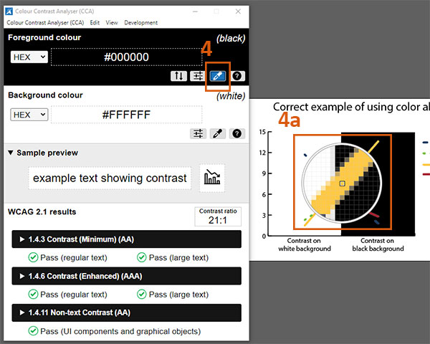
- Next, select the dropper tool in the Background Colour section, following the same process in step 4.
- Review the results in the WCAG 2.1 results section near the bottom of the application window. This section displays the results of the color contrast ratio between the two select color combinations.
  - If the color combination does not pass, you must increase the darkness of one of the colors or find a different color combination.
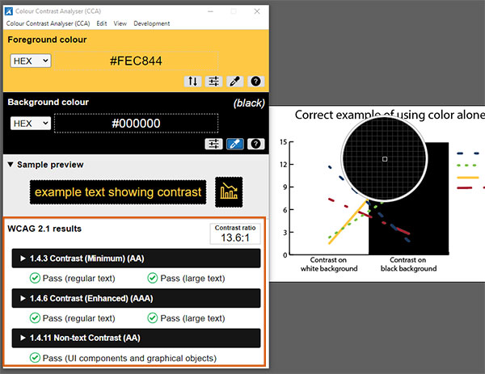
Colour Contrast Analyser video tutorial – created by Berkely University, walks you through how to use the application.

Testing tools for mobile

VoiceOver on iOS (iPhone and iPad)
VoiceOver is the screen reader built into Apple iOS devices.

Resources
- Apple’s Turn on and Practice VoiceOver on iPhone.
- How to Navigate your iPhone or iPad with VoiceOver
- Deque University Quick Reference Guide: VoiceOver for iOS
- Deque University Quick Reference Guide (with Images): VoiceOver for iOS.

Turn VoiceOver on
- Go to Settings
- Scroll down and tap Accessibility.
- Tap VoiceOver at the top.
- Toggle the setting on or tell Siri to “Turn on VoiceOver.”

Turn VoiceOver off
- Go to Settings
- Scroll down and tap Accessibility.
- Tap VoiceOver at the top.
- Toggle the setting off or tell Siri to “Turn off VoiceOver.”

Enabling Caption Panel
The VoiceOver Caption Panel displays the text VoiceOver speaks at the bottom of the screen. Having this turned on is very helpful for accessibility testing. If the Caption Panel text is too small, you can enlarge it by adjusting your iOS text size settings.
- Go to Settings
- Scroll down and tap Accessibility.
- Tap VoiceOver at the top.
- Scroll to the bottom and toggle the Caption Panel switch on.
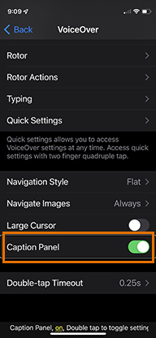

Basic Usage
- Use a single tap to select an item.
- When selecting an item, such as buttons or a hyperlink, double-tap anywhere on the screen to select it.
- Swipe left or right with one finger to move to the previous or next item.

TalkBack on Android
TalkBack is the screen reader included with Android OS.

Resources
- Android Accessibility Help to learn how to use TalkBack.
- Navigate your device with TalkBack
- Deque University Quick Reference Guide: TalkBack 9.1+for Android.
- Deque University Quick Reference Guide (with Images): TalkBack 9.1+ for Android

Turn TalkBack on
- Go to Settings
- Tap on Accessibility.
- Tap on TalkBack and toggle the switch to on.

Turn TalkBack off
- Go to Settings
- Tap on Accessibility.
- Tap on TalkBack and toggle the switch to off.

Basic Usage
- Use a single tap to select an item.
- When selecting an item, such as buttons or a hyperlink, double-tap anywhere on the screen to select it.
- Swipe left or right with one finger to move to the previous or next item.

Enable Caption Preference
- Go to Settings
- Tap on Accessibility.
- Scroll to Hearing enhancements
- Select Caption Preferences.
- Toggle the Show Captions to on. You can also adjust the caption size and style from this screen.
